Healthcare and AI: Analyzing COVID-19 Outcomes and Detecting AI-Generated Texts

Nishant Nayak Msc in Data Analytics
National College of Ireland
Dubin, Ireland
x22248242@student.ncirl.ie

Abstract—COVID Deaths and Vaccinations project introduces two datasets capturing the global spread of COVID-19 from January 2020 to August 2024. One dataset track cases, deaths, and population demographics, revealing mortality patterns across populations. The second dataset records vaccination counts globally, highlighting daily and cumulative totals. Analysis shows vaccinations significantly reduced death rates but reveals disparities in vaccine distribution among countries. This project, situated in epidemiology, global health, and public policy, emphasizes the importance of equitable vaccine access and reliable data for informed policymaking.
The LLM-Detect AI-Generated Text Dataset comprises 28,000 articles comparing human-written and AI-generated texts. It addresses concerns about AI-generated content being misrepresented in education, publications, and content creation. The dataset spans diverse subjects and writing types, analyzing patterns in linguistic structure, coherence, and topicality to distinguish human from AI-generated texts. Falling under natural language processing and AI applications, the project supports developing classification tools and advancing text classification technologies critical for education and ethical AI use.
Keywords— Covid Death Analysis (Total Deaths, Total Cases, ICU patients, Hospital Patients), Vaccination Rate Analysis (Total cases, gdp per capita, median age, life expectancy, population density, aged_65_older, aged_70_older, diabetes prevalence, Hospital Beds per thousand).

Introduction
The COVID Deaths and Vaccinations project introduces two datasets capturing the global spread of COVID-19 from January 2020 to August 2024. One dataset tracks cases, deaths, and population demographics, revealing mortality patterns across populations. A second dataset globally records the number of vaccinations, whether on a daily or overall basis. A comparative study shows a significant drop in mortality rates after vaccinations, yet there remain disparities between countries for inoculation. However, we will study the number of ICU patients using the other features such as total deaths, total cases, and hospitalized patients. The model will analyze the relationship between these features and the target variable (ICU patients) in order to make predictions. This project, located within the fields of epidemiology, global health and public policy, urgently underscores the necessity in both principle and practice of providing vaccines equitably and trustworthy data for making informed policies. The dataset LLM-Detect AI-Generated Text includes 28,000 papers comparing actual articles that editors have written with their AI-generated counterparts.
It responds to concerns over AI-generated content being misrepresented in education teaching materials, academic papers, research articles and original works. The dataset features works in various fields and writing types, which are used for styles and topics different from traditional ones. The project lies within natural language processing, applications of AI in industry supplemented education and transformative uses for texts; it supports the development of classification tools refining text classifications technologies critical to Education and responsible AI development.

Related Work

The COVID-19 Hospital Beds and ICU Patients Analysis looks at the relationship between medical infrastructure (such as the number of hospital beds per thousand persons and the quantity of ICU patients) and the impact of COVID-19 on a series of dependent variables, including total infected cases, deaths and how much healthcare system capacity stretches.

The LLM-Detect AI Text Generation project and its corpus of 28,000 articles comparing human-authored and AI-generated texts seek to respond to the detection of AI content from genuine human high concerns in this era. The advent of AI models such as GPT-3 and GPT-4 has made content credibility a problem, especially in the context of education and publishing.

Key aspects of related works include:

Healthcare Infrastructure and Pandemic Response: Studies have demonstrated the crucial role of healthcare infrastructure in managing the impact of pandemics. For instance, the availability of hospital beds and ICU capacity is directly related to the number of severe COVID-19 cases a hospital can accommodate, which in turn influences mortality rates. Countries with higher hospital bed capacity and more ICU units have been better able to manage patient surges during the pandemic.

Language Model-based detection of AI's influence on English writing. Study isolated features in English content and thought about how AI language models get an influence on these levels. They also related to the implications for input data of linguistic influence or irregularity: if some placeholder change would make amounts of my previous work into misleading but key conclusions just because it got a few less words in there.
LLM-Detect makes a step forward using AI to compare articles written by human authors and those generated by machine, addressing the question of false or machine-made creation.

Epidemiological Studies on Death and Case Rates:

Several studies, such as those conducted by the CDC, WHO, and other public health organizations, show how hospitals with more resources are better equipped to handle outbreaks and reduce the number of deaths. For example, higher ICU capacity is correlated with better management of critical cases and lower death rates. On the other hand, insufficient hospital and ICU beds can lead to overwhelmed healthcare systems, higher mortality, and longer recovery times.

Influencing Factors:

GDP, Age, and Health Conditions: The relationship between healthcare infrastructure and COVID-19 outcomes can be influenced by several socio-economic and demographic factors. Variables like GDP per capita, median age, life expectancy, population density, and the prevalence of conditions like diabetes have been found to correlate with both hospital bed capacity and the severity of COVID-19 cases. For example, countries with higher GDP per capita generally have better healthcare systems, which can absorb the burden of a pandemic more effectively.

Text Classification Models:
AI algorithms have long been used to identify machine generated texts. For example, computer measures the word length, vocabulary choice and sentence data - comparing these different statistics with known parameters if they fall into ranges characteristic of ordinary human speech and writing, then regard the document as human-generated. The LLM-Detect group offers a solid and wide range of resources on how to build up such models.
This is also significant because constant AI-generated content is turned out from the masses in sectors like education, journalism and research publication where the question of accuracy and originality is most urgent.

Population Demographics:

Studies have highlighted the importance of aged populations, particularly those aged 65 or older, as they are more vulnerable to severe outcomes from COVID-19. The presence of such vulnerable groups in a population requires more hospital resources and ICU beds to ensure their care. As such, regions with a higher proportion of older individuals, such as those over 65 and 70 years of age, tend to have higher healthcare demands.

Critical Evaluation:

Advantages / Strengths: The analysis provides valuable insights into the direct relationship between hospital and ICU capacity and COVID-19 outcomes like mortality and case severity. It helps inform public health decisions about resource allocation during a pandemic, particularly in terms of the need for more hospital beds and ICU units. This information is crucial for governments and healthcare organizations to plan for future health crises.
LLM-Detect dataset with 28,000 samples is a considerable resource available to create more reliable AI detection technology. The other side is that it will promote text classification techniques of all types, by training on readily available human-written materials versus those created in machines (or fake names).

Limitations or Drawbacks
A significant limitation for COVID 19 dataset is the variability in healthcare data reporting across countries and regions. Some countries may report healthcare data more accurately, while others may have incomplete or outdated information. Additionally, while healthcare infrastructure is important, this analysis often overlooks the effectiveness of non-medical factors, such as public health interventions, testing rates, and adherence to preventive measures (e.g., masking and social distancing).
One guiding difficulty for the LLM-Detect AI Text Generation dataset is a potential Bias in its construction. Since it relies on a corpus of samples produced by AI models to training its network sample, it did not cover all types of AI generated text (such as that produced from non-GPT models). Also, AI-generated language features change rapidly so that models trained on this corpus may not be applicable for future generations of AI language models.
Other challenge is to develop a machine learning model that can accurately detect whether an essay was written by a student or an LLM. The competition dataset comprises a mix of student-written essays and essays generated by a variety of LLMs

Key Aspects to Consider:

Future studies should examine not only the availability of hospital beds but also the distribution of these resources, especially in low-income countries or rural areas where healthcare systems may be less equipped to handle large-scale crises. In addition, socio-economic factors such as age distribution, lifestyle diseases like diabetes, and population density must be included to fully understand the health system's preparedness for such a pandemic.

While the AI text generated data set presents a solid basis for differentiating human writing from text produced by an AI, researchers must still pay attention to analog aspects such as the poetry of AI editing and how to detect sophisticated AI-produced texts. Detect systems must be produced that can keep up with future progress in AI's writing perspicacity as well heighten our own powers of discrimination toward this new dimension of speech.

Data Mining Methodology

- Business Understanding:

There are two main goals for the project:
COVID-19 Statistics: In COVID-19 dataset, we can analyze some interesting information about the population of cases and severity levels. We can also derive useful patterns that can help in planning of health care.
Human vs AI-Generated Essays Classification: We can create a machine learning model that can classify whether an essay was written by a human or generated by AI, helping to detect AI-generated content.
Both of these goals contribute to the larger mission of using data-driven methods to address real-world problems in the healthcare and technology sectors.
- Data Understanding:

COVID-19 Dataset:
All major data related to total number of COVID death cases and Vaccination doses with respect to the world’s population. Key attributes include:
total_deaths : Total deaths due to COVID-19 in a given area/country. It is a measure of pandemic severity and its toll. Utilized for calculating mortality and comparing outcomes across different areas.

total_cases : The total number of confirmed cases of COVID-19 in the region. It provides some perspective on how widespread the outbreak might be, as well as how effective containment measures might be. Normalized by population, it tells us how intense the spread is.

hosp_patients : Total number of COVID-19 patients currently hospitalized. It provides insight into the burden on and capacity utilization of the health care system. Applicable for planning resource allocation as well as evaluating hospitalization rates.

icu_patients : The number of COVID-19 patients currently in treatment in intensive care units (ICU). It shows the severity of the pandemic. Helps assess ICU bed needs and the pressure on critical care resources.

gdp_per_capita : The average economic output per person, measured by Gross Domestic Product (GDP) per capita. It allows for a surrogate for the level of economic development and the quality of health care infrastructure. Countries with higher GDP per capita generally have better pandemic mitigation systems available.

median_age : The median age of a population in the region. It provides insight into the age distribution in the population. Increased vulnerability may lead to higher hospitalization and mortality rates in older populations.

life_expectancy : The average number of years that a person can expect to live , based on current mortality trends. It is an important measure of regional health and well-being. It might have something to do with the efficiency and performance of the healthcare system.

population_density : Number of people per square kilometer in the region. More densely populated communities have faster virus transmission rates, making this a key consideration in how to assess at-risk populations and plan interventions.

aged_65_older : Percentage of the population 65 years and older. Older population are known to be at higher risk for severe outcome and mortality. It is a helpful statistic in allocating resources for elder care.

aged_70_older : Proportion of the population 70 years or older. It simply looks at a higher than the average risk group than aged_65_older. It is essential for the modeling of healthcare service utilization and mortality rates.

diabetes_prevalence : The percentage of population with a diagnosis of diabetes. It is an established risk factor for severe COVID-19 outcomes. Healthcare strategies may need to be specialized for high-prevalence regions.

hospital_beds_per_thousand : The number of available hospital beds per 1,000 people in the region. Importance: Reflects healthcare system capacity. A higher figure indicates better preparedness to deal with a spike in cases.

Human vs AI-Generated Essays Dataset:
Dataset contains essay texts and metadata -
text: The main essay content.
title: The title of the essay.
generated: Binary target variable indicating Human (0) or AI (1).
Distribution analysis shows a balanced dataset with a slightly higher count for AI-generated essays.
- Initial Exploration:

Dataset Source:
CovidVaccinations.csv contains socio-economic, health, and demographic data.
Relationships between numeric features are observed using a heatmap. Strongly correlated features are identified to avoid multicollinearity in modeling.
Key predictors (gdp_per_capita, median_age, life_expectancy, population_density, aged_65_older,
aged_70_older, diabetes_prevalence) are chosen, and the target variable is hospital_beds_per_thousand.
Missing values exist in critical columns like gdp_per_capita and hospital_beds_per_thousand.
The data is loaded from a CSV file (CovidDeaths.csv) containing various columns like total_cases, total_deaths, icu_patients, etc.

The data was loaded for COVID 19 dataset and structure was checked using: df.head(), df.info() for overview and descriptive statistics: df.describe().
Key findings: Total deaths highly correlated with total cases and average I.C.U. admissions. Extracted and visualized top five correlation for further exploration. Highly correlated variables can indicate redundancy or significant predictive relationships.

Training Essays: Human vs AI-Generated: The data was loaded from a CSV file (Training_ Essay_ Data.csv)and structure was checked using: data.head(), data.info() for overview and descriptive statistics: data. describe().
A Correlation matrix was calculated to determine relationships and patterns in numeric features.

- Exploratory Data Analysis:

Dataset Overview:

The dataset contains the following key features:

Death Analysis:

Features (X): total_deaths, icu_patients, hosp_patients.
Target (y): total_cases
COVID Vaccination Rate:
Features (X): gdp_per_capita, median_age, life_expectancy, population_density, aged_65_older, aged_70_older, diabetes_prevalence.
Target (y): hospital_beds_per_thousand.
Training Essays data:
Features (X): X is created by dropping the target_column ('generated') from the dataset. This means X initially contains all columns of data except the target column ('generated').
Later, when text preprocessing is performed on the text_column ('text') using TF-IDF, the resulting matrix is combined with the remaining features in X (excluding the text_column) to form X_final, which is the fully prepared feature set used for training and testing.
Target (y): generated.
Correlation Analysis:
A correlation heatmap showed strong relationships between total_deaths and total_cases, supporting its inclusion in the feature set.
The code identifies numeric columns with data.select_dtypes(include=['float64']).
A correlation matrix is computed to reveal relationships between numeric features, which helps in identifying strong or weak dependencies among variables.
Correlation heatmap helps identify relationships between numerical features.

Data Preparation

Missing Values:

The dataset was checked for missing values in the selected features. Appropriate handling strategies, such as mean imputation, were employed where necessary to ensure data consistency. Missing values in numeric data are initially filled with zeros and then handled using the fillna() and dropna() methods.

Missing data in critical columns such as gdp_per_capita, aged_70_older, aged_65_older, etc., are dropped to ensure data quality and consistency for modeling.
Features (X) and the target variable (y) are explicitly defined as: Socioeconomic and demographic indicators like gdp_per_capita, median_age, life_expectancy, population_density, aged_65_older, aged_70_older, diabetes_prevalence. Target: hospital_beds_per_thousand (number of hospital beds per thousand people).
Missing values are indirectly handled using apply() functions, for instance, during text preprocessing and feature engineering. Explicit imputation strategies are not showcased but could be added as needed.

Data Cleaning: Irrelevant columns were dropped, and missing values were addressed to ensure the dataset's consistency.

Splitting Data:

COVID-19 Death: The dataset was split into training and testing sets using an 80-20 ratio (test_size=0.3) with random_state=42 for reproducibility.
COVID-19 Vaccination: The dataset is split into training (80%) and testing (20%) with (test_size=0.2) and random_state=42.

Pre-processing data:

Text Preprocessing:
Text in the text column is cleaned using the clean_text() function.
This involves:
Removing square-bracketed content, URLs, punctuation, numbers, and extra whitespaces.
Converting text to lowercase.
Stopwords are removed, and text is tokenized using tokenize_and_remove_stopwords().
Date Preprocessing:
The preprocess_date() function converts date strings into standard datetime format, managing parsing errors.

- Feature Engineering and Data Transformation

- Feature Selection:
A linear regression model is constructed within a StandardScaler pipeline.
StandardScaler was applied to normalize numerical features, ensuring they have comparable scales for modeling.
Metrics such as mean squared error (MSE), R2 (R-squared), and adjusted R2 are calculated to evaluate the regression model's performance.
Key features influencing hospital capacity (hospital_beds_per_thousand) are selected based on domain knowledge and correlation analysis. These include median_age, life_expectancy, gdp_per_capita, population_density, diabetes_prevalence, and age-related features.

- Data Transformation:
Features were prepared in a pipeline to integrate data preprocessing and model training seamlessly.
TF-IDF Transformation: The TfidfVectorizer converts cleaned text data into a numerical format. Only the top max_features terms (e.g., 1000) are retained to reduce dimensionality.
Feature Combination: TF-IDF features are concatenated with existing numerical features in the dataset using pd.concat.
- Modelling and Interpretation
- Algorithm:
Linear regression was used due to its interpretability and suitability for continuous target prediction.
GradientBoostingRegressor from sklearn.ensemble is chosen for its robust handling of non-linear relationships and feature importance estimation.
- Training:
The model was trained using the training set to learn the relationships between the features and the target variable.
The model is fit on the training data to learn the relationships between features and the target.
Predictions:
Predictions are made on the test set using the trained model (y_pred = model.predict(X_test)).
K-Nearest Neighbors (KNN):
A KNN model is trained with n_neighbors=5 on the TF-IDF transformed features. Model performance is evaluated using accuracy and classification metrics like precision, recall, and F1-score.
Random Forest Classifier:
A Random Forest model is trained using RandomForestClassifier with 100 estimators. Evaluation metrics include accuracy, confusion matrix, and misclassification rate.
Here we have classified the machine learning models and techniques into respective divisions depending on their type & functionality that is used in the project:
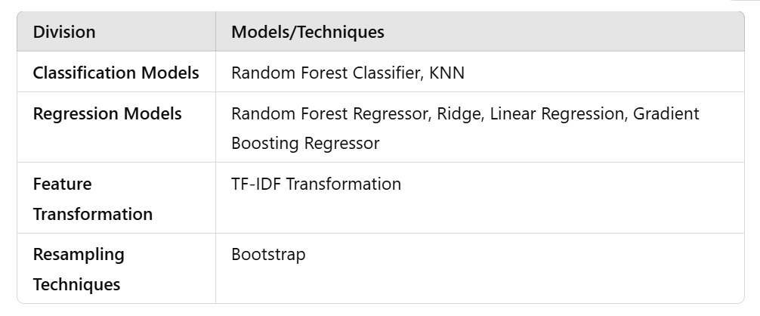

Evaluation And Visualisation

Testing Performance:
The model's performance was evaluated on the test set using the following metrics:
Mean Squared Error (MSE): Measures average squared difference between predicted and actual values.
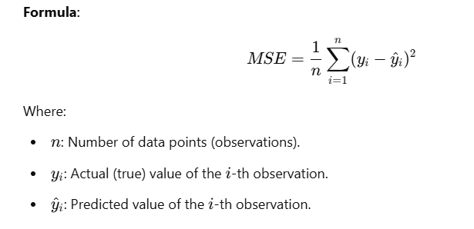
R-squared (R²): Proportion of variance in the target variable explained by the model.
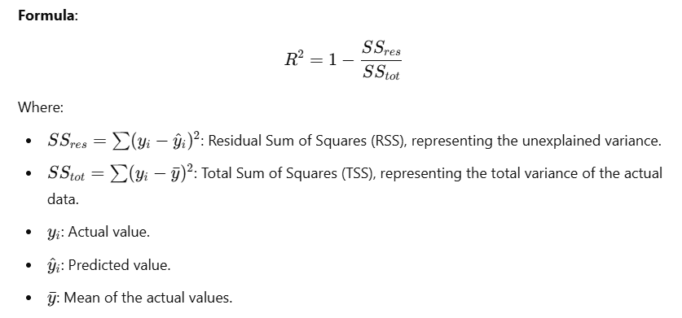
Adjusted R-squared: Adjusts R² for the number of predictors, penalizing the inclusion of irrelevant features.
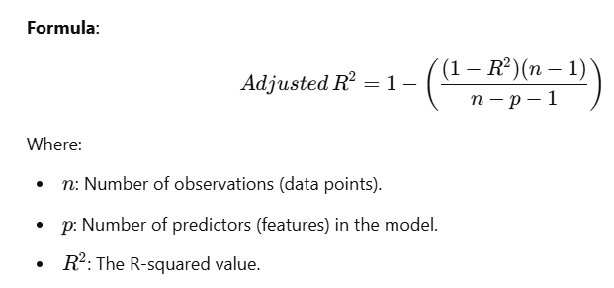

- Key Findings:
COVID-19 Death Dataset:
The resulting model had an acceptable R² value, suggesting that the features we used accounted for a significant proportion of the variance in total_cases.
Mean Squared Error (MSE) on the test set is the mean of the squared difference between the actual and predicted values. If the numeric features of a dataset have high values, the MSE (Mean Squared Error) could also be higher. Thus, as with the target variable or features with large values, small prediction errors can result in large errors after squaring. Small numbers, when squared, increase the magnitude of the error dramatically: for instance, squaring an error of 100 results, in 10,000, while squaring an error of 0.1 results in 0.01. This means that any large value in the data set will amplify the squared error, hence it will subsequently result in a greater one.
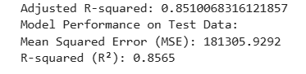
Adjusted R-squared (0.8510) shows that the model explains 85.1% of the variance, adjusted for the number of predictors.
MSE (181305.9292) is relatively high, indicating that the model has some significant errors, though this depends on the scale of the target variable.
R-squared (0.8565) shows that 85.65% of the variance is explained by the model, which is a strong result.
Adjusted R-squared:
The value was computed to validate the model's robustness when adjusted for the number of predictors.
COVID-19 Vaccinations Dataset:
The Mean Absolute Error (MAE) of 0.3004 indicates that, on average, the predictions made by the model deviate from the actual values by approximately 0.3 units. MAE, as it does not square the differences between predicted values and actual results, is less sensitive to large errors as compared to MSE. Thus, this allows easier interpretation in terms of the error size in the same units as the target variable. A good MAE means the model is good in prediction.

MAE = 0.3004: On average, the model is off by 0.3 units, which is a relatively low error, indicating good predictive accuracy.
R² = 0.9729: The model explains 97.29% of the variance in the target variable, which indicates an excellent fit and strong model performance.
LLM - Detect AI Generated Text Dataset:
Classification Report:
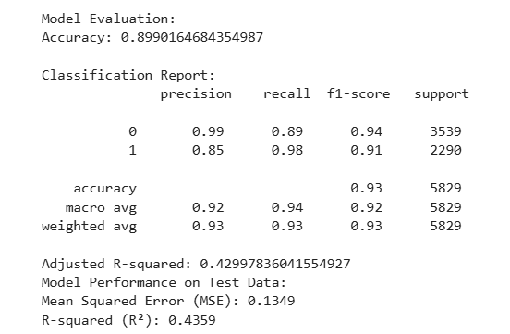
The classification report provides several important metrics to evaluate the performance of a classification model.
Precision gives the number of positive predictions that were correct.
In the case of Class 0: Precision = 0.99, it signifies that 99% of the classes predicted as Class 0 are right.
Class 1: Precision = 0.85 implies that out of all the instances predicted as class 1, only 85% was correct.
Recall (also known as sensitivity or true positive rate) is the proportion of actual positive instances that were identified correctly.
Class 0: Recall = 0.89: it means that the model identified 89% of the real Class 0 instances.
In case of Class 1, Recall = 0.98 indicates that the model was able to identify 98% of the true Class 1 instances accurately.
F1-Score is the harmonic mean of precision with recall that provides a balance between two.
F1-Score = 0.94, providing a fair balance between precision and recall. For Class 1: F1-Score = 0.91, quite decent overall performance but slightly worse than class 0 because of a balance in precision.
Accuracy: 0.93 means that 93% is the overall accuracy of the model that is correctly classified. Although this is a good score but can be deceiving on imbalanced classes (if both classes do not evenly engage).
Macro Average: It is like micro average, but used to get average of precision, recall and F1 of each class — ignore the imbalance of classes. Macro Precision = 0.92 | Macro Recall = 0.94 | Macro F1-Score = 0.92 This indicates a balanced performance between the two classes.
R-squared is typically used for regression models (continuous target variable), so in classification tasks, R-squared might not be as informative, especially when the target is categorical.
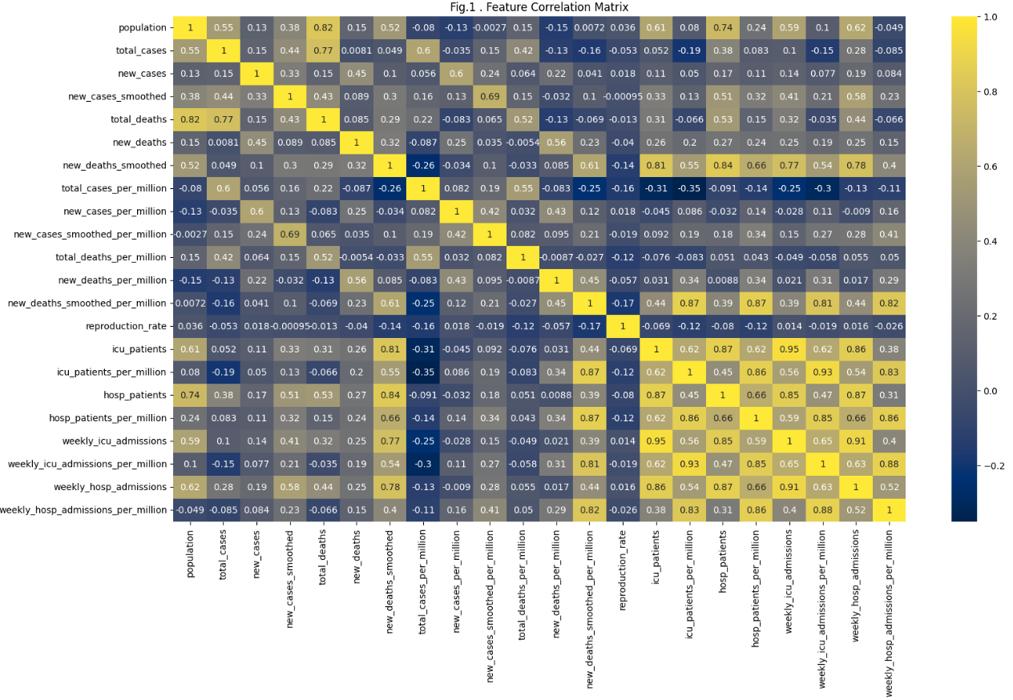
The title of the plot, "Fig.1: Feature Correlation Matrix", indicates that the matrix shows the correlation coefficients between different features in the dataset.
The correlation between hosp_patients and icu_patients is approximately 0.87.
This indicates a strong positive correlation, meaning that an increase in hospital patients is often associated with an increase in ICU patients.
total_cases and total_deaths also have a strong positive correlation (0.77), likely because higher cases typically lead to more deaths.
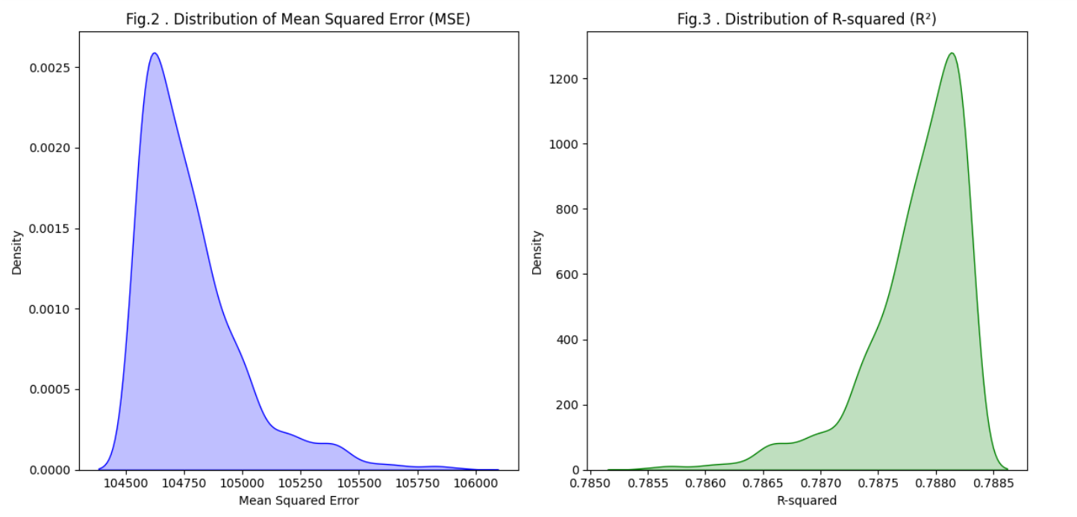
The graphs in the image Fig.2 and Fig.3 display the distribution of two key metrics—Mean Squared Error (MSE) and R-squared (R²)—commonly used to evaluate the performance of regression models.
The MSE values are distributed around approximately 104,760, with some minor spread (as seen from the density curve).
This indicates the model's error varies slightly across multiple evaluations but remains centered around this value.
The R² values are tightly distributed around approximately 0.787. This suggests that the model explains about 78.7% of the variance in the target variable, with little fluctuation in R² across evaluations.

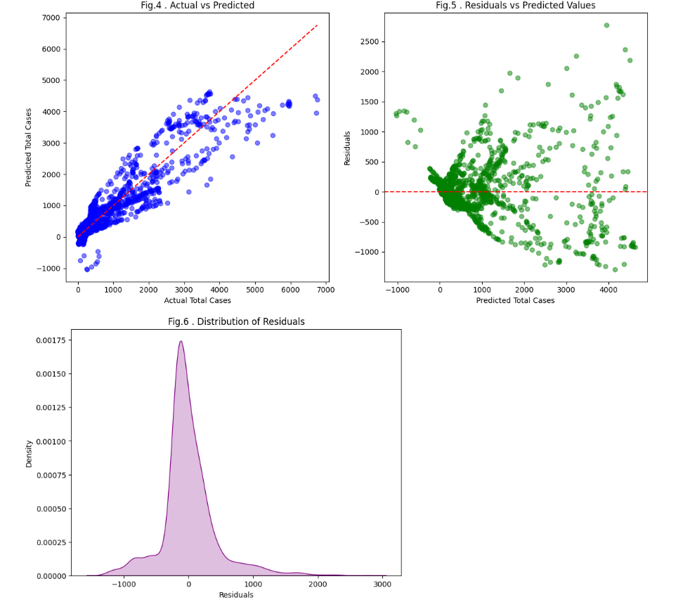
The scatter plot in Fig.4 compares the actual target values (on the x-axis) with the predicted values (on the y-axis) from the regression model. The red dashed line represents the "ideal" fit line where predicted values perfectly match actual values (i.e., y=x). Points are generally clustered along the red line, indicating good predictions. However, there is some spread as the actual values increase, suggesting that the model's predictions may deviate more for larger values.
Fig.5 visualizes residuals (differences between actual and predicted values) against predicted values to assess model fit.
Residuals = (Actual – Predicted).
So, the residuals are centered around zero which is a good sign. Instead, a clear fan-shaped pattern emerges where residuals increase with predicted values. This suggests possible heteroscedasticity (non-constant variance of residuals). Residuals are generally larger for larger predictions, indicating a potential shortcoming of our model to capture extreme variations.
Variable prediction is limited in cases with a larger expected value that the model may not fully capture.
Fig. 6 - Distribution of Residuals is the distribution plot for normality check. The residuals are roughly symmetric about zero with a bump around zero. All 3 variables exhibit slight skewness and no extreme outliers.
Residuals are approximately normally distributed, which supports one of the key assumptions in most regression models. This lends validity to the model.
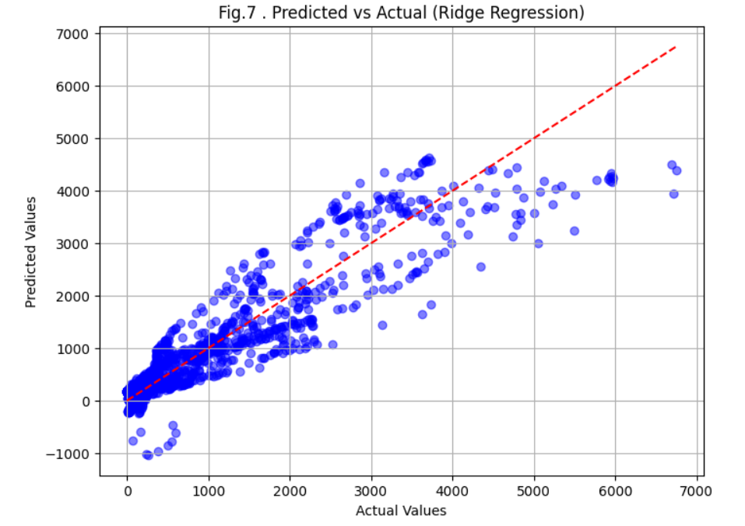
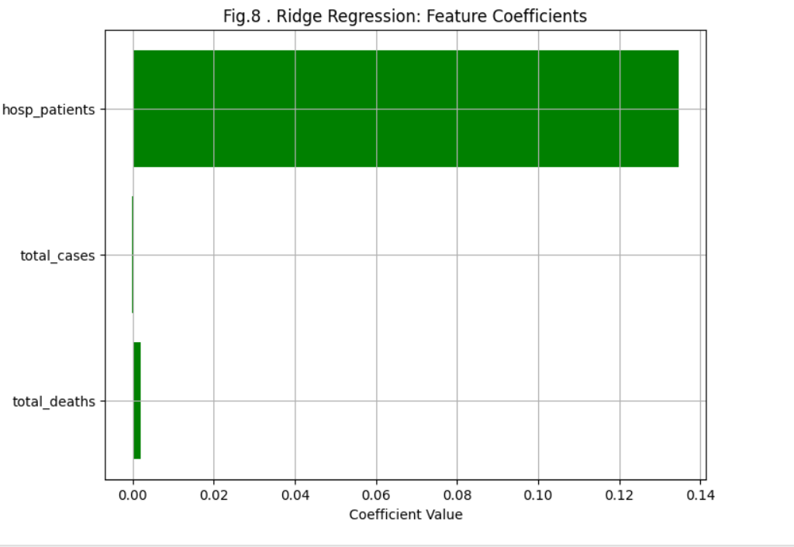

Fig. 7 is a scatter plot which shows real values (x-axis) vs predicted values (y-axis) of Ridge Regression model
Key Features: Blue Points — That is what the predictions from model.
Red Dashed Line: A line at a 45-degree angle indicating the perfect prediction case where the predicted values are identical to the actual values.
The points track closely with the red dashed line, indicating that the model makes reasonably accurate predictions. Yet, there are a few jumps (some points are at a much larger distance from the line) and they represent errors in prediction.
Fig.8 is the bar chart that received the weights of each feature by the Ridge Regression model. The values of these coefficients show features contributing to the target variable. Key Features: Features (y-axis): hosp_patients : Highest coefficient (kind of most important for predictions). total_cases: The hosp_patients_coeff is very small, much smaller than the population assigned cases.
total_deaths: This is the least contributing feature. Coefficient Value (x-axis): Represents the impact of each feature on the predictions made by the model.
Ridge regression regularization (penalty on the size of coefficients) has probably forced the coefficients of the less relevant features (total_cases and total_deaths) to be very small while still paying attention to hosp_patients.

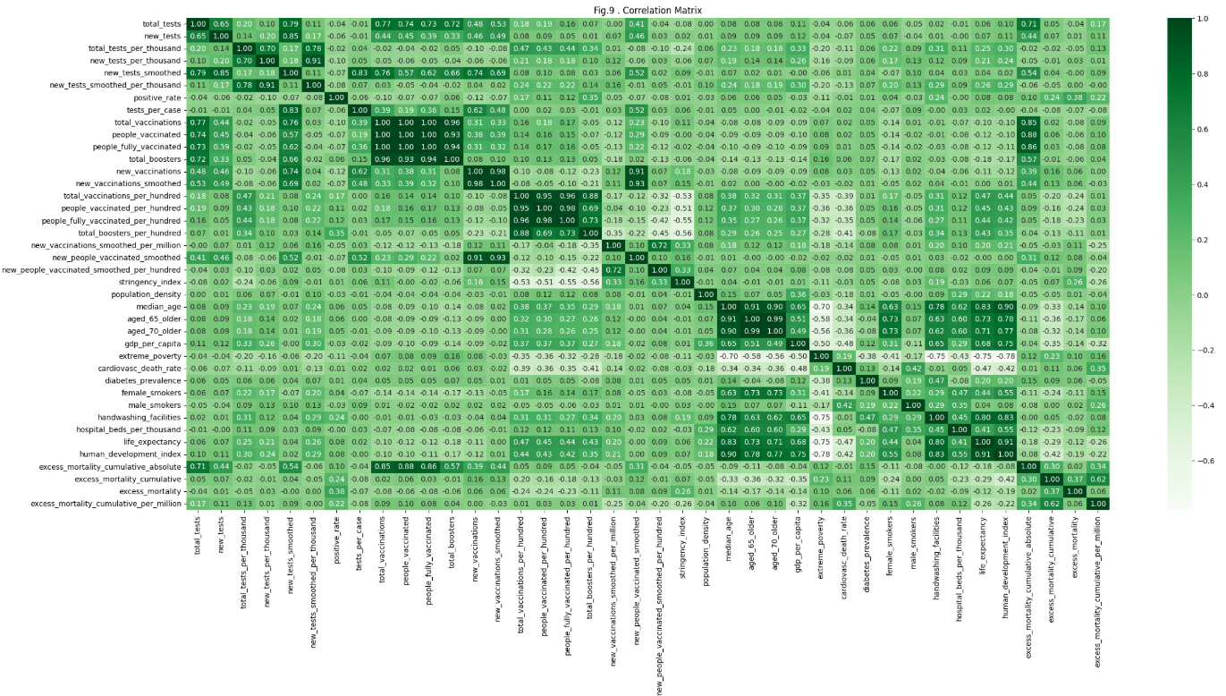
The plot shown in Fig.9 is a correlation matrix, which provides a heatmap representation of the Pearson correlation coefficients between various features in a dataset
Features like aged_65_older and aged_70_older might be strongly correlated with one another, as they measure related aspects of age demographics.
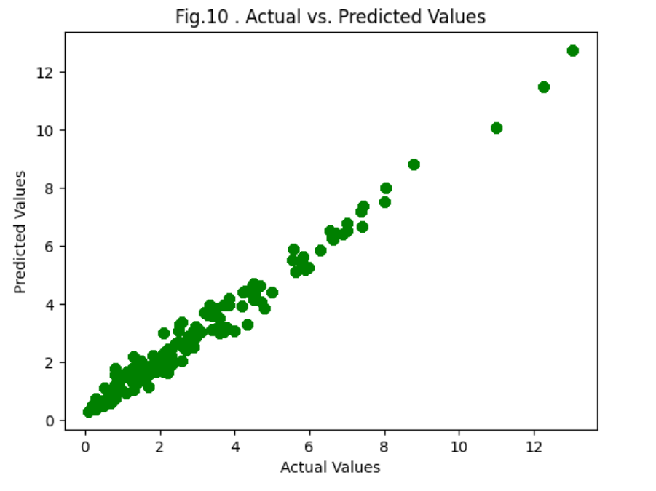The performance of the regression model employing the selected features to predict hospital_beds_per_thousand is evaluated using this scatterplot in Fig.10 above.
The points are clustered near the diagonal, signaling that our model is making fairly accurate predictions. But there is also some scatter around the diagonal, which means that there are moments where the predictions deviate from the actual values (prediction error). This fit indicates both that the features are likely working reasonably well at predicting the target variable.
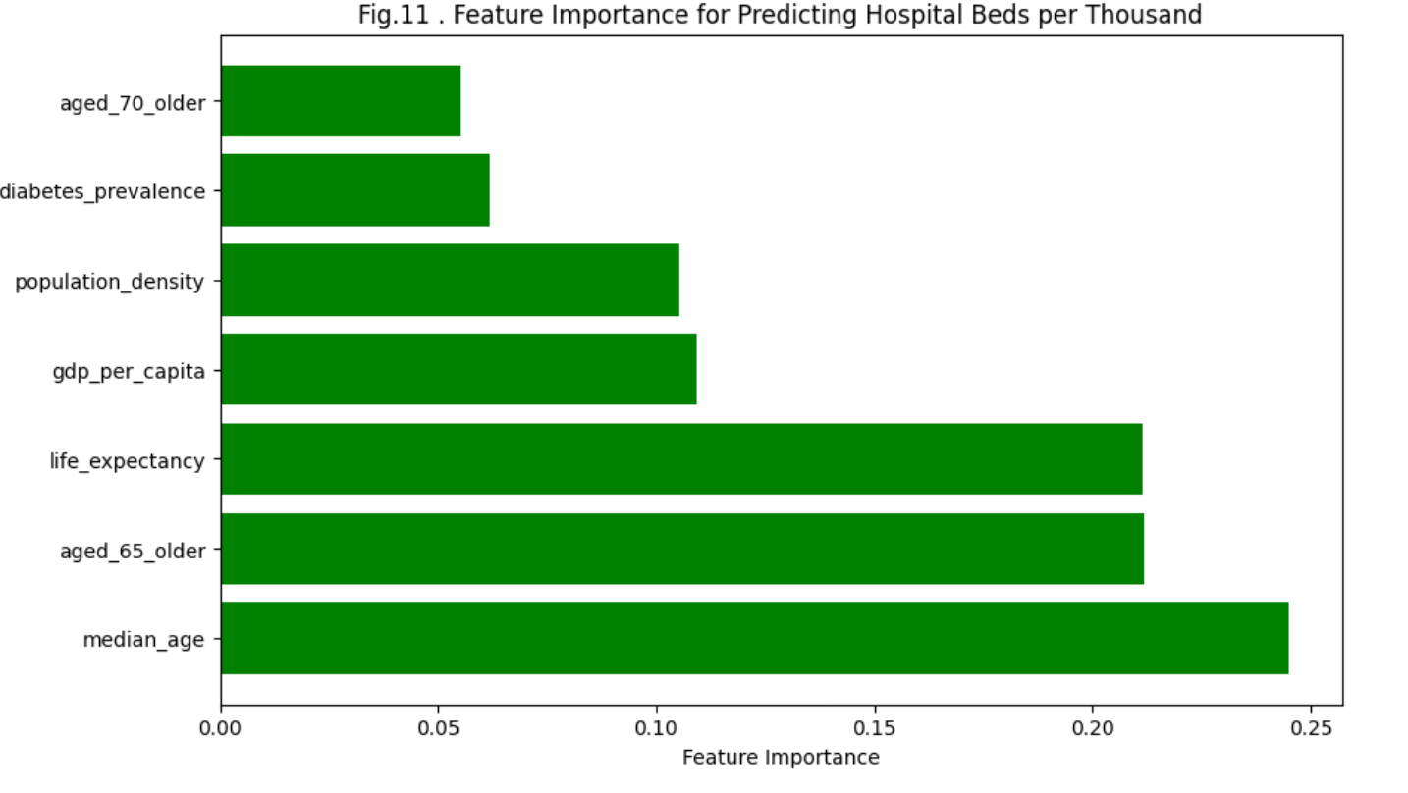
Fig.11 is a bar plot shows the importance of each feature in predicting the number of hospital beds per thousand.
Feature importance in predicting the no of hospital beds per 1000.
Key Features:
median_age: The most powerful predictor. Higher availability of hospital beds in relatively wealthier and more aged regions is likely due to an older median age.
aged_65_older: This corresponds with a demographic need for more healthcare resources to be devoted to older populations.
life_expectancy: Better healthcare systems generally lead to longer life expectancy.
gdp_per_capita: Suggests that economic factors do also play a role in the availability of hospital beds, but to a lesser extent than demographics.
population_density: Moderate importance, perhaps because the number of hospital beds does not necessarily scale with population density.
aged_70_older: Fairly important, echoing the healthcare needs of the very old.
diabetes_prevalence: least predictive, public health concern but does not correlate directly with hospital beds.
Insights: Median age, aged 65 older, life expectancy as demographic factors are the most important when it comes to predicting the number of hospital beds. Economic and health factors such as gdp_per_capita and diabetes_prevalence matter less.
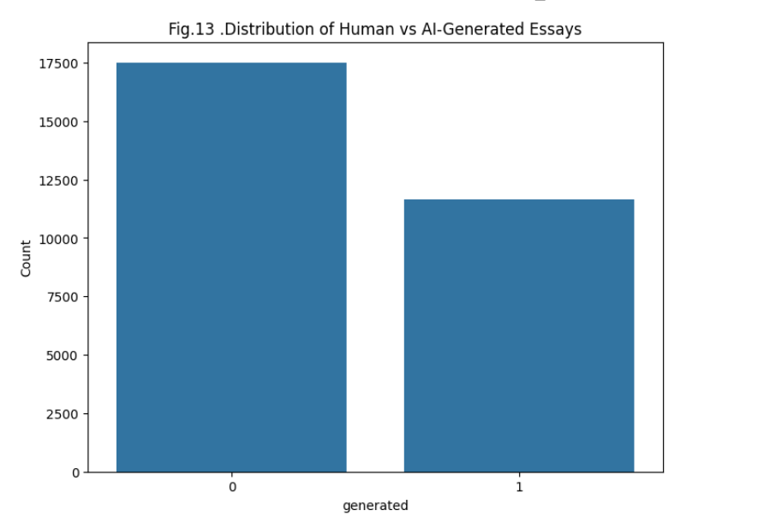
Fig. 13: Distribution of Human vs AI-Generated Essays is a bar chart showing the counts of essays written by humans versus those generated by AI.
The x-axis (0 and 1) displays the type of essay:
0: Human-written essays ; 1: AI-generated essays.
Y-axis (Count):
The y-axis is the number of essays in each category.
Bars: Then, the first bar (the one indicating 0) is much taller because there are a lot more human written essays (about 17500). The second bar (right, showing 1) is a shorter bar, which is the number of AI generated essays (about 12,500).
Observations: Human-essays outnumber AI-essays by near seven to one in the dataset. Although both categories differ, the difference is not enormous, which indicates a relatively balanced dataset with a prevalent amount of human-written data.
Use Case: This distribution is most likely a piece of a more extensive investigation, like constructing a model that classifies the text into AI or human essay. Maintaining a balance between the two buckets is important to deliver a performing and fair model.
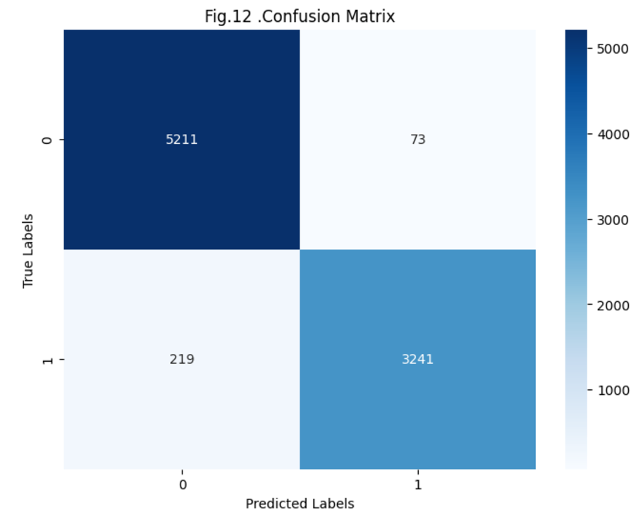
Fig.12 A confusion matrix expresses the accuracy of a classification model in a visual representation. It shows the number of true positives, true negatives, false positives, and false negatives. The model did an amazing job at predicting human generated essays (0) (5211 correct predictions and only 73 errors.) For essays generated by OpenAI (1), the number of correct predictions was 3241, and the number of false classifications was 219. This means that the predictions are mostly correct, because the true positive and true negative, cells contain more values. There are very few misclassifications (FP and FN), it proves that the accuracy of the model is also very high

Conclusion And Future Work:

In analyzing the COVID-19 Death and Vaccination Dataset alongside the s, several key insights emerge. The COVID-19 dataset sheds light on population health dynamics. The 28K student and AI essays highlight trends in textual creativity, sentiment, and the ever-changing influence of machine intelligence in education and assessment.
Integrate: Investigate relationships between public sentiment (from essay sentiment analysis) and vaccination rates or health results to analyze possible correlations between societal perceptions and pandemic management. Improved Modelling: The modelling aspect can be beefed up by leveraging vastly improved machine learning techniques like transformers to increase the accuracy of the classification of the essays and the extraction of more granular trends between the student vs AIGC generated content.

Policy Recommendations: Design Recommendations based on the vaccination and mortality analysis for Future Pandemic Preparedness with slightly more focus on Vaccine Equity.

References

- “COVID 19 Dataset.” Accessed: Dec. 14, 2024. [Online]. Available: https://www.kaggle.com/datasets/rhonarosecortez/covid-19-dataset
- sunil thite, “LLM - Detect AI Generated Text Dataset,” Kaggle.com, 2023. https://www.kaggle.com/datasets/sunilthite/llm-detect-ai-generated-text-dataset/data
- ‌“Application of Random Forest Algorithm on Feature Subset Selection and Classification and Regression | IEEE Conference Publication | IEEE Xplore.” Accessed: Dec. 14, 2024. [Online]. Available: https://ieeexplore.ieee.org/document/8074494
- M. Kayri, I. Kayri, and M. T. Gencoglu, “The performance comparison of Multiple Linear Regression, Random Forest and Artificial Neural Network by using photovoltaic and atmospheric data,” in 2017 14th International Conference on Engineering of Modern Electric Systems (EMES), Jun. 2017, pp. 1–4. doi: 10.1109/EMES.2017.7980368.
- A. Liaw and M. Wiener, “Classification and regression by randomForest. R News 2 (3): 18–22.” 2002.
- A. Behnamian, K. Millard, S. N. Banks, L. White, M. Richardson, and J. Pasher, “A Systematic Approach for Variable Selection With Random Forests: Achieving Stable Variable Importance Values,” IEEE Geosci. Remote Sens. Lett., vol. 14, no. 11, pp. 1988–1992, Nov. 2017, doi: 10.1109/LGRS.2017.2745049.
- R. Corizzo and S. Leal-Arenas, “A Deep Fusion Model for Human vs. Machine-Generated Essay Classification,” in 2023 International Joint Conference on Neural Networks (IJCNN), Jun. 2023, pp. 1–10. doi: 10.1109/IJCNN54540.2023.10191322.
- D. R. Cutler et al., “Random forests for classification in ecology,” Ecology, vol. 88, no. 11, pp. 2783–2792, Nov. 2007, doi: 10.1890/07-0539.1.
- “The elements of statistical learning: data mining, inference and prediction | The Mathematical Intelligencer.” Accessed: Dec. 14, 2024. [Online]. Available: https://link.springer.com/article/10.1007/BF02985802
- Probabilistic Outputs for Support Vector Machines and Comparisons to Regularized Likelihood Methods,” ResearchGate. Accessed: Dec. 14, 2024. [Online]. Available: https://www.researchgate.net/publication/2594015_Probabilistic_Outputs_for_Support_Vector_Machines_and_Comparisons_to_Regularized_Likelihood_Methods
- “Pattern Recognition and Machine Learning | SpringerLink.” Accessed: Dec. 14, 2024. [Online]. Available: https://link.springer.com/book/9780387310732
- “Evaluating the Impact of Vaccination on COVID-19 Pandemic Used a Hierarchical Weighted Contact Network Model | IEEE Conference Publication | IEEE Xplore.” Accessed: Dec. 14, 2024. [Online]. Available: https://ieeexplore.ieee.org/document/9624841
- L. Standaert, T. Munasinghe, D. Jang, C. Tate, S. Lossef, and W. Wong, “Covid Vaccine Risk Stratification,” in 2021 IEEE International Conference on Big Data (Big Data), Dec. 2021, pp. 4421–4425. doi: 10.1109/BigData52589.2021.9671601.
- J. Liu, M. Zhang, and X. Hu, “DMML: A Design Thinking Process Modeling Language,” in 2011 12th International Conference on Computer-Aided Design and Computer Graphics, Sep. 2011, pp. 44–48. doi: 10.1109/CAD/Graphics.2011.56.
- T. K. Dash, C. Chakraborty, S. Mahapatra, and G. Panda, “Gradient Boosting Machine and Efficient Combination of Features for Speech-Based Detection of COVID-19,” IEEE J. Biomed. Health Inform., vol. 26, no. 11, pp. 5364–5371, Nov. 2022, doi: 10.1109/JBHI.2022.3197910.

